**Daily record 2021-4-29**

(1) draw glyphs function:

plot_HARDI_along_tracts, adapted from E_DTI_plotHARDI_blobs, input is ROINr, output is glyphs in the seedROI_

plot_HARDI_along_tracts2, instead of ROINr, input is points along tracts, two ways to get the input: either from saved tracts.mat files, the points location is stored in .mat Tracts variable, or when EDTI is open, read in data.tracto strucutrre.

Improvement of _tracts2 function, from ploting all the ttracts CSD FOD one by one, we plot one tract and delete the previous one. This way only one single tract FODs remains on the graphic interface. Glyphs scale is adjusted to real scale as well, using parameter h_sc =1/2.

What I found: regardless of going one step further function I worked on the past weeks, there is the potential to resolve the bottomneck problem. At the end of a tract, normally the peak being followed is < threshold 0.1, but meanwhile there is an obvious AFD direction, like perpendicular to the direction being followed. Condition, when AFD of peak2 is more than 3 times larger than AFD peak 1 (and peaks 2< thresh), tracts should turn into theAFD peak 2 direction.

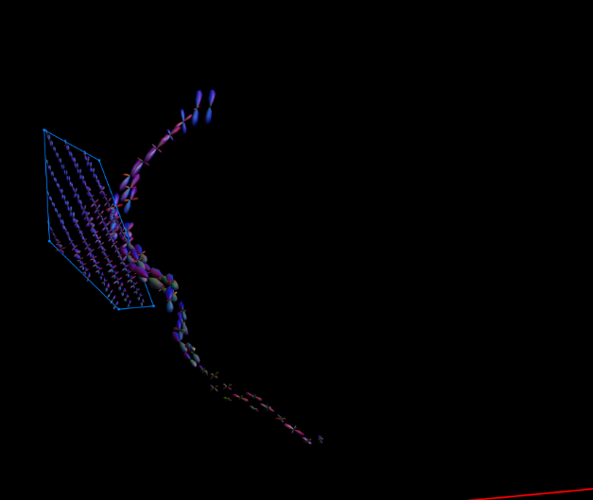 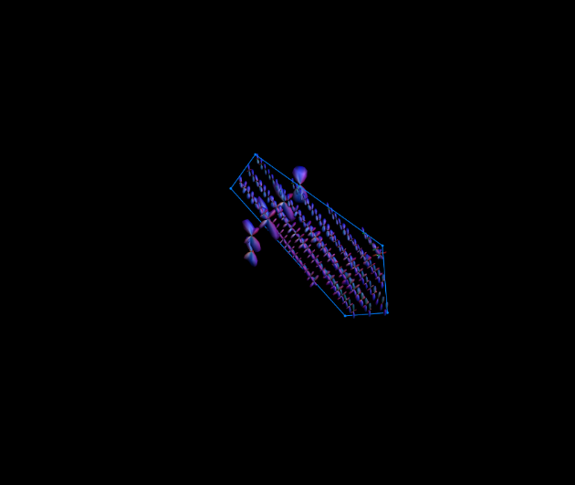

(2) some peaks, like i27/100307, show a clear failture when two peaks merges into one. i.e. angle resolution reaches maximum. (figure). In this case, maybe use NuFO, when AFD number suddenly changes, try to give two or multiple directions instead of one peak.

(3) the U-turn feature may work even better in cortical regions (mentioned in what I found para_1). Important argument: one main direction doesn’t mean only one streamline is passing through, the number of streamlines are not homogeneously allocated along the fibers: singles fibers, because of its high AFD, may have much more fibers/streamlines going through (bottomneck) the voxels. More weighting should be added onto the large AFD voxels (e.g. voxels showing a dominant main fiber orientation).

**Next step**: quickly implement the code, using AFD to advise tractography to resolve the bottomneck problem. (afd1>3afd2)

**Daily record 2021-6-1**

2) code: calc_fod_subject_mask_local->calc_fod_lobe_pervoxel_2

3) code:

plot_HARDI_along_tracts2->plot_tract_along_with_glyphs->E_DTI_TractLines_Analysis_Process_FH

4) tractend has been added into each cell of fList

5) mapping points back onto coordinates, /VDims (e.g.. /1.25 for 100307)

6) plot_HARDI_along_tracts2->E_DTI_Get_tract_entries->E_DTI_sub2ind

To Do: 1) add afd in the tracking process (Calculate_Tracts_CSD_Det_2), line 45

Line 76,77, Tractend/TractCSDFOD ->Tracker_FG_7

2) Adjust hardi fod position/use points interpolation (positions are rounded currently)

3) Plot with thicker lines for tracts

**Update 2021-8-22**

ToDo 1) 2) 3) is done.

Nextstep is done, but doesn’t really improved tracking results.

There is something clearly doesn’t work in the code. Tracts stops but both the magnitude threshold and the angular threshold were fit. Double check each streamlines.

D:\Matlab_files\100307\100307_tracts_t1\Tracts_th01_and.mat

Plot_fof_along_tracts.m

Dirs0512, asymmetrical.